SIMATS ENGINEERING (SAVEETHA SCHOOL OF ENGINEERING)
Department of Computer Science and Engineering

ASSESSMENT TOOL 2 – Industry Problem Solving Task

Course Code: | CSA06 | Course Title: | Design and Analysis of Algorithms
CO Assessed: | CO4: Articulation (BL4, BL5) | Assessment: | Assessment Tool 2 – Industry Problem Solving Task
Weightage: | 20% of CIA | Total Marks: | 100
CO4 Statement: | Solve optimization problems using dynamic programming and greedy strategies.
Student Name: | Shyam sundhar Y | Reg. No.: | 192424082
Section / Batch: | SLOT B | Date: | 24.08.2026

Instructions to Students
- Answer the following question. Total Marks: 100.
- Carefully analyze the given questions.
- Explain in detail with sample code if needed.
- Clearly identify all key issues.
- Provide a thorough analysis with validated results and performance evaluation.

Question Type | Focus Area | Questions
Industry Problem Solving Task | Focus on Solving optimization problems using dynamic programming and greedy strategies | Q1

SECTION A – Industry Problem Solving Task

Code of Conduct
I Shyam sundhar Y (Name / Reg No) certify that this submission is my original work and that I have adhered to the guidelines specified for this assessment. I understand that any violation of academic integrity rules will result in disciplinary action.
Signature of the Student: Shyam sundhar Y

RUBRICS FOR CALCULATION

Industry Problem Solving Task

Criteria | Weightage | Level 4 – Exemplary | Level 3 –  Proficient | Level 2 –  Developing | Level 1 –  Beginning
Understanding of  Industry Problem | 20% | Comprehensive understanding of  real-world problem and constraints | Good understanding with minor gaps in requirements | Basic understanding; some  requirements unclear | Poor understanding; misinterprets problem context
Application of  Engineering  Concepts | 25% | Applies advanced and relevant concepts  effectively to solve the problem | Applies appropriate  concepts with minor errors | Limited application of concepts | Incorrect or no application of concepts
Solution Design | 25% | Innovative, practical, and feasible solution  aligned with industry standards | Logical and feasible solution with minor gaps | Basic solution with limited feasibility | Unclear or impractical solution
Use of Tools | 15% | Effective use of modern tools,  technologies, and real  data | Appropriate use of tools with correct implementation | Limited or inconsistent use of tools | Minimal or incorrect use of tools
Analysis | 10% | Thorough analysis with validated results and performance evaluation | Good analysis with reasonable validation | Basic analysis with limited validation | Poor or no analysis
Professionalism | 5% | Highly professional, well-documented,  and clearly presented  work | Good documentation and presentation | Basic documentation with some gaps | Poor documentation and presentation

Marks Evaluation:
Criteria | Wt. | Level 4 –  Exemplary | Level 3 –  Proficient | Level 2 –  Developing | Level 1 –  Beginning
Understanding of Industry Problem | 20%
Application of Engineering Concepts | 25%
Solution Design | 25%
Use of Tools | 15%
Analysis | 10%
Professionalism | 5%
Total Marks (100):

Faculty In-charge | Course Coordinator | Head of Department
Name: | Name: | Name:
Signature: _______________ | Signature: _______________ | Signature: _______________
Date: ___________________ | Date: ___________________ | Date: ___________________

ASSESSMENT TOOL 2 – Industry Problem Solving Task

NAME: S.SRI MATHI
REG.NO: 192424095
COURSE CODE: CSA0603
COURSE NAME: DESIGN AND ANALYSIS OF ALGORITHM
DATE: 24.08.2026

Q35. Autonomous Drone Delivery Routing (Graph + Optimization)
A logistics company uses drones to deliver packages efficiently across a city. Analyze how path planning algorithms can optimize delivery routes. Identify constraints such as battery life and obstacles. Design a solution using graph-based optimization techniques. Discuss scalability for multiple drones. Evaluate performance metrics. Interpret results in logistics automation.

1. Problem Statement
A logistics company wants to use autonomous drones to deliver packages from a warehouse or drone station to multiple customer locations.
The main problem is to find a route that is:
- Shortest or fastest
- Safe from obstacles and restricted areas
- Within the drone's battery range
- Able to carry the required package weight
- Efficient when several drones are operating simultaneously
This is a real-world graph optimization problem. The delivery locations and possible flight paths can be represented as a graph, and optimization algorithms can be used to select efficient routes.

2. Real-Time Industry Scenario
This technology is mainly used in the logistics, e-commerce, food delivery and healthcare industries.
A strong current example is Amazon Prime Air. As of August 2026, Amazon announced plans to expand drone delivery to nearly 500 U.S. cities and towns by the end of 2026. Its MK30 drone can operate up to about 7.5 miles from a delivery facility, and Amazon uses onboard cameras, sensors and a Detect-and-Avoid system for autonomous navigation.
Another current example is DoorDash Air, which received FAA Part 135 certification in July 2026 and is developing its own drone delivery operation. DoorDash is integrating drones with its existing delivery network rather than treating drones as a completely separate system.
Also, in August 2026, Uber and Zipline announced a partnership to introduce autonomous drone delivery for Uber Eats in the U.S., showing that drone routing is becoming part of mainstream food-delivery logistics.
So this problem is not theoretical. Autonomous route optimization is an important part of modern last-mile logistics.
3. Graph Representation
The city can be represented as a weighted graph:
G=(V,E)

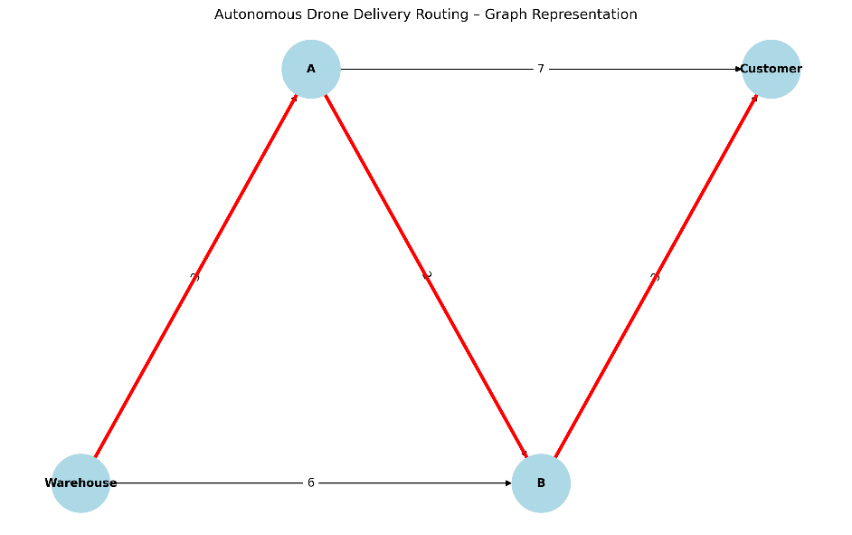
Where:
- V (Vertices) = warehouse, drone stations, customer locations, charging stations and safe landing/drop points.
- E (Edges) = possible flight paths between locations.
- Edge weight = distance, travel time or energy required.

4. Constraints in Drone Routing
A simple shortest-path problem is not enough because a real drone has physical and operational limitations.

a) Battery Constraint
The drone cannot travel farther than its available battery allows.
For example:
Energy(Route)≤BatteryCapacity
If a route requires 80% battery but the drone has only 70% available, that route must be rejected.
The system should also maintain a safety reserve instead of allowing the battery to reach zero.
b) Obstacles
The drone must avoid:
- Buildings
- Towers
- Bridges
- Power lines
- Trees
- Restricted airspace
- Other aircraft/drones
An obstacle can be represented by removing an edge from the graph or assigning it a very high cost.
Amazon's current Prime Air system, for example, uses onboard sensing and a Detect-and-Avoid system to make real-time decisions about its surroundings.
c) Payload Constraint
The drone has a maximum carrying capacity.
PackageWeight≤DroneCapacity
A package exceeding the drone's capacity cannot be assigned to that drone.

d) Delivery Time
Some packages may have a deadline.
For example:
Food order must reach the customer within 30 minutes.
Therefore:
DeliveryTime≤Deadline

e) Weather
Rain, strong wind and poor visibility can affect:
- Battery consumption
- Flight speed
- Safety
- Route availability
Therefore, the routing system should dynamically update the graph when weather conditions change.

5. Optimization Approach
A suitable solution can combine Greedy algorithms, Dynamic Programming and graph algorithms.

Step 1 – Construct the Graph
Create a graph containing:
- Warehouse
- Customers
- Charging stations
- Safe flight corridors
- Obstacles
Assign weights such as:
Weight=Distance+EnergyCost+RiskCost
The lowest-weight route becomes preferable.

6. Greedy Strategy – Dijkstra's Algorithm
For finding the shortest path between two locations, Dijkstra's algorithm can be used when edge costs are non-negative.

Working
- Start from the warehouse.
- Set warehouse distance to 0.
- Set all other nodes to infinity.
- Select the unvisited node with the smallest cost.
- Update the costs of its neighboring nodes.
- Repeat until the destination is reached.

Example
If:
Warehouse → A = 3 km
Warehouse → B = 6 km
A → B = 2 km
B → Customer = 3 km
A → Customer = 7 km
The algorithm compares:
Warehouse → A → Customer
= 3 + 7
= 10 km
and
Warehouse → A → B → Customer
= 3 + 2 + 3
= 8 km
Therefore:
Selected route = Warehouse → A → B → Customer

7. Dynamic Programming for Delivery Planning
When the drone has to visit multiple customers, the problem becomes more complex.
For example:
Warehouse
↓
Customer A
↓
Customer C
↓
Customer B
↓
Warehouse
The system must determine the best order of visiting customers.
This resembles the Travelling Salesman Problem (TSP) and, with multiple drones, the Vehicle Routing Problem (VRP).
Dynamic programming can be used for smaller numbers of delivery locations by storing solutions to previously solved subproblems.
For example:
DP[S][i]
can represent the minimum cost of visiting the set of customers S and ending at customer i.
This avoids repeatedly calculating the same routes.

Important limitation
Dynamic programming becomes expensive as the number of customers increases.
Therefore, it is suitable mainly for small or moderate routing problems, while large real-world systems generally need scalable heuristics, optimization methods and real-time planning.

8. Multi-Drone Optimization
Suppose there are:
Warehouse
/ | \
Drone1 Drone2 Drone3
↓ ↓ ↓
A → B C D → E
The problem is no longer just:
"What is the shortest route?"
It becomes:
Which drone should deliver which package, and what route should each drone follow?
This is a Multi-Drone Vehicle Routing Problem.
The system should optimize:
- Drone assignment
- Delivery sequence
- Total distance
- Battery usage
- Delivery time
- Collision avoidance
- Charging requirements
A practical system can use:
Greedy algorithm → initial assignment
followed by:
Optimization/DP/heuristic → improve routes
And Real-time replanning → respond to obstacles/weather/battery changes
Recent research in 2026 is also exploring multi-robot task allocation and routing using optimization methods such as ant colony optimization. One recent study reported improvements in travel distance and completion time compared with baseline methods.

9. Proposed Algorithm

Input
- Number of drones
- Customer locations
- Warehouse location
- Distances
- Battery capacities
- Package weights
- Obstacles
- Delivery deadlines
- Weather conditions

Processing
START
↓
Create city graph
↓
Mark obstacles/restricted
locations
↓
Calculate edge costs
↓
Check battery constraint
↓
Assign packages to drones
↓
Find optimized routes
↓
Check time + safety constraints
↓
Send route to drone
↓
Monitor drone in real time
↓
Obstacle/weather detected?
/ \
YES NO
↓ ↓
Recalculate route Continue
\ /
\ /
Delivery completed
↓
END

10. Pseudocode
START

Input:
Graph G
Warehouse W
Customers C
Drones D
Battery capacity
Package weights
Obstacles

For each drone:
Check available battery
Check package weight

Remove unsafe/blocked edges from G

For each customer:
Find shortest feasible route
using graph-based optimization

If battery constraint is violated:
Find charging station
Recalculate route

Assign customers to drones
while minimizing:
total distance
energy consumption
delivery time

For multiple customers:
optimize delivery sequence

During flight:
monitor battery
monitor obstacles
monitor weather

If conditions change:
update graph
recalculate route

Return optimized delivery plan

END

11. Performance Evaluation
Metric | Purpose
Total distance | Measures route efficiency
Delivery time | Measures speed
Battery consumption | Measures energy efficiency
Number of successful deliveries | Measures reliability
Route computation time | Measures algorithm speed
Obstacle avoidance rate | Measures safety
Battery-return failures | Measures operational reliability
Drone utilization | Measures fleet efficiency
Cost per delivery | Measures economic efficiency
The proposed system can be evaluated using the following metrics:

12. Scalability
For one drone and a few customers, Dijkstra or dynamic programming can work effectively.
But as the number of drones and customers increases, the problem becomes much more complex.

Small system
1 Drone
5 Customers
↓
DP / Dijkstra

Medium system
5 Drones
50 Customers
↓
Greedy + optimization

Large system
100+ Drones
1000s of Customers
↓
Distributed optimization
+ heuristics
+ real-time replanning
+ AI/ML
A large-scale system should therefore avoid recalculating every possible route from scratch.
Instead, it can use:
- Hierarchical routing
- Greedy assignment
- Heuristic optimization
- Parallel computation
- Real-time graph updates
- Dynamic task allocation
This is particularly important because real delivery networks continuously change.

13. Real-Time Dynamic Routing
A major difference between a classroom graph and a real drone system is that the graph changes while the drone is flying.
For example:
Original:

Warehouse → A → B → Customer
↓
shortest

New obstacle detected:

Warehouse → A → 🚫 → Customer
↓
Recalculate
↓
Warehouse → C → D → Customer
Therefore, the drone should not blindly follow a route calculated before takeoff.
It should continuously receive information from:
- GPS
- Cameras
- LiDAR/sensors
- Weather systems
- Battery sensors
- Airspace information
and update the route when necessary.
Amazon's current Prime Air system explicitly uses onboard cameras and sensors for navigation and obstacle detection, along with its Detect-and-Avoid system.

14. Industry Interpretation
This solution has significant applications in last-mile logistics.

E-commerce
Companies can deliver small packages directly from fulfillment centers.

Food delivery
Restaurants can use drones for short-distance food deliveries, reducing dependence on road traffic.

Healthcare
Drones can transport:
- Medicines
- Blood samples
- Vaccines
- Emergency medical supplies
This is particularly useful where road transportation is slow or difficult.

Disaster management
Drones can deliver essential supplies to areas affected by:
- Floods
- Earthquakes
- Cyclones
- Landslides

Why it matters
Traditional delivery vehicles are affected by:
- Traffic
- Road conditions
- Fuel costs
- Driver availability
Drones can potentially bypass road congestion and provide faster point-to-point delivery, provided that battery, safety, airspace and weather constraints are satisfied.

15. Latest Industry Connection – 2026
The industry is moving from experimental drone delivery toward integrated autonomous logistics networks.
As of August 2026:
- Amazon is planning to expand Prime Air to nearly 500 U.S. cities and towns by the end of 2026.
- Amazon's FAA documents describe MK30 operations with an operating range of about 7.5 miles and proposed operations of up to 1,000 delivery flights per day from a delivery center, depending on the specific approved operation.
- DoorDash has launched DoorDash Air after receiving FAA Part 135 certification, integrating drones with its broader autonomous delivery strategy.
- Uber and Zipline announced an autonomous drone-delivery partnership for Uber Eats, showing the movement toward combining drones with existing delivery platforms.
This proves why graph optimization is relevant: when the number of drones, customers and delivery locations increases, manually planning routes becomes impossible.

16. Advantages

1. Faster delivery
Drones can avoid road traffic.

2. Lower travel distance
Graph optimization selects efficient paths.

3. Better battery utilization
Energy constraints prevent inefficient routes.

4. Improved safety
Obstacle-aware routing avoids dangerous regions.

5. Better fleet utilization
Multiple drones can be assigned different customers.

6. Real-time adaptability
Routes can be recalculated when conditions change.

7. Reduced human dependency
Autonomous routing reduces manual route planning.

17. Limitations
The solution is not perfect.

Battery limitation
Current batteries restrict flight range and payload.

Weather
Strong wind, heavy rain and poor visibility can affect operations.

Airspace regulations
Drones cannot simply fly anywhere.

Computational complexity
Multi-drone routing becomes extremely difficult as the number of customers increases.

Infrastructure
Charging stations and drone hubs are required.

Safety and privacy
Autonomous drones operate near homes, roads and people.

Noise
Large-scale drone operations can create community concerns.
These are real deployment issues, not merely theoretical constraints. Current Amazon expansion plans, for example, still involve regulatory, environmental and community considerations.

18. Expected Outcome
The proposed graph-based optimization system should produce:
The safest and most efficient feasible route for each drone while minimizing distance, energy consumption and delivery time.
For multiple drones, the system should additionally minimize:
Total Cost=Distance+Energy+Time+Risk
subject to:
Battery≤Capacity Payload≤MaximumPayload DeliveryTime≤Deadline

19. Conclusion
Autonomous drone delivery routing is a real-world optimization problem in the logistics and last-mile delivery industry. A city can be represented as a weighted graph where locations are vertices and possible flight paths are edges. Greedy graph algorithms such as Dijkstra's algorithm can identify efficient paths, while dynamic programming can help optimize delivery sequences for smaller routing problems.
For multiple drones, the problem becomes a multi-drone vehicle-routing and task-assignment problem. Battery capacity, payload, obstacles, weather, delivery deadlines and restricted airspace must be incorporated into the optimization process. Real-time monitoring allows the system to recalculate routes when conditions change.
The approach can reduce delivery time, travel distance and battery consumption while improving drone utilization and operational safety. The growing deployment of Prime Air, DoorDash Air and Uber-Zipline demonstrates that autonomous delivery is becoming an increasingly important part of modern logistics.

